*DiabeTrack: Smart Diabetes Monitoring and*

*Lifestyle Assistant*

*(Sept 2025)*

*AMIRTHA R DEEPIKA P*

*DEPARTMENT OF CSE DEPARTMENT OF CSE*

*PANIMALAR ENGINEERING COLLEGE PANIMALAR ENGINEERING COLLEGE*

***Abstract* - Diabetes is one of the big health challenges around the world, calling for effectives means of monitoring and managing so that complications could be reduced and improvements in patient outcomes ensured. Traditional methods, including finger-prick testing and invasive continuous glucose monitoring, are mostly costly, inconvenient, and inaccessible for long-term use. Recent developments in wearable technologies, combined with AI and ML, have opened up newer vistas for non-invasive, real-time glucose monitoring and personalized lifestyle management.The paper proposes a comprehensive system for diabetes management using wearable devices that integrates wearable devices, Firebase cloud service, machine-learning-based risk prediction, and smart reminders. A real-time dataset was used to record, track, and visualize glucose trends dynamically from connected glucose monitoring devices and user lifestyle inputs. This allows users to receive personalized recommendations for their lifestyle modification and synchronization of health data securely across devices.This predictive model makes use of real-time data to facilitate early detection of risks related to hyperglycemia and hypoglycemia, thus helping intervene on time and preventively. Evaluation results indicate that DiabeTrack gives very good accuracy in glucose prediction, wearable data is successfully integrated, and users can follow better routines due to smart reminders. The system represents a major step toward AI-driven patient-centric diabetes management ecosystems and has great potential for scalability related to broad healthcare.**

***INDEX ITEMS - Diabetes, Artificial Intelligence, Wearable Device, Real Time Dataset, Risk Prediction, Non-invasive Monitoring, Smart Healthcare***

1. ***INTRODUCTION***

Diabetes, or diabetes mellitus, has become one of the most important chronic metabolic disorders of the 21st century; it affects hundreds of millions of people worldwide, therefore seriously affecting health systems and economies worldwide. According to estimates by IDF, the number of adults with diabetes will increase from 537 million in 2021 to over 700 million by 2045, hence the urgent need for newer strategies in management and prevention. The disease increases morbidity and mortality rates besides significantly affecting the quality of life and productivity of the patients, especially in cases when the blood glucose level is poorly controlled.

Effective and continued monitoring of blood glucose levels has a significant role in reducing the complications such as hypoglycemia, neuropathy, retinopathy, and cardiovascular diseases. However, till today, most of the traditional glucose monitoring techniques are invasive, expensive, and cumbersome to follow over a longer period with conventional glucose monitoring systems using either finger-prick tests or CGM systems [7]–[9]. This produces poor adherence, smaller data availability, and a lack of actionable insights by the patients and clinicians.

Recent development in AI, ML, and wearable sensors has presented a paradigm shift toward the development of noninvasive, intelligent, and patient-centered diabetes management systems [1]–[4]. AI-driven prediction models showed promising accuracy in forecasting glucose excursions and early risk detection that facilitates proactive intervention [2, 5, 12]. Wearable devices like smartwatches and PPG-based sensors provide continuous, real-time physiological data acquisition, promoting user engagement and personalized management in diabetes care [6, 12, 19].

Despite these, there is a significant amount of lag regarding the integration of multi-source health data, intelligent decision-making, and user-friendly lifestyle management into a single, integrated framework. This paper, therefore, proposes a system, DiabeTrack, that will introduce an integrated, cloud-connected comprehensive platform combining wearable integration, ML-driven glucose risk prediction, adaptive smart reminders, and personalized lifestyle insights. Considering a real-time dataset from wearable glucose sensors and user input, the system will dynamically perform the analytics and visualization of glucose trends to continuously monitor and provide recommendations. With real-time data analytics and intuitive end-user interaction, DiabeTrack tends to empower diabetic users with actionable intelligence, better compliance, and more engaging self-management capabilities. This work will present the comprehensive design, architecture, and implementation of DiabeTrack, together with performance evaluation and future research directions. By consolidating modern AI analytics, non-invasive sensing, and intelligent health coaching, DiabeTrack constitutes a major milestone toward a smarter, more approachable, and preventive management of diabetes.

## LITERATURE REVIEW

Diabetes mellitus is a chronic metabolic disorder, which requires continuous monitoring of blood glucose levels, regular medication, and maintenance of particular lifestyles. Traditional monitoring approaches include manual record-keeping and static reminders, but these have their great pitfalls because of reliability on patients' compliance. Missed readings or forgotten medication could lead to serious health complications, making the need for smart, automated systems more critical.

In the last couple of years, IoT, AI, and cloud-based technologies have been aggressively adopted for making diabetic care robust. IoT-enabled glucose monitoring devices and Bluetooth glucometers avoid manual input and reduce errors while collecting real-time data. Alhaddad and Thomas [18] discussed the advances in wearable technology and non-invasive sensor-based detection of glucose, which would be effective only if all the devices are integrated to collect credible data. The healthcare system gets more robust as Firebase has allowed the storing, synchronization, and real-time access of patients' data across all their devices safely [4].

The prediction models driven by AI have also been considered for diabetes management. Moon and Raut [8] discussed the role of machine learning algorithms in identifying abnormal glucose patterns, predicting the risks of hyperglycemia or hypoglycemia. Alkalifah et al. [11] proposed a predictive framework using the metrics from continuous glucose monitoring and achieved high accuracy in classifying potential risk events. This means that prediction helps not only in early warnings but also maintains better medical interventions.

Medication adherence is another important aspect of diabetes care. Digital solutions such as adaptive reminders and personalized alerts have shown to improve adherence among diabetic patients with the use of digital devices. Rodriguez-León et al. [9] reviewed mobile and wearable technology for monitoring diabetes and concluded that interactive, context-aware reminders yield better compliance compared to static notifications. Other recent interest has focused on wearable technologies. Smartwatches and fitness trackers are often integrated into modern healthcare systems to collect lifestyle information around activity, heart rate, and sleep. Put together with glucose monitoring, this device can present a much broader view of a patient's health. Integration with such devices has been demonstrated to result in improved prediction accuracy and user engagement [6].

Despite progress, existing systems still have limitations. Many focus solely on logging glucose values without providing intelligent insights. Others lack adaptive reminders, wearable integration, or predictive alerts, leaving patients vulnerable to unexpected complications.

Based on these findings, the proposed system DiabeTrack integrates three key modules:

Glucose Monitoring Module: to capture and store glucose readings in real time using the Web Bluetooth API on a live dataset collected from wearable glucometers and user interaction.

Risk Prediction Module: It will analyze the glucose pattern and predict the possible risks of abnormal fluctuations based on the real-time dataset.

Smart Reminder Module: The adaptive, personalized alert system for medicine compliance and other regulative actions in life. Integrating real-time monitoring with predictive intelligence and wearables, DiabeTrack covers the chasm left between existing solutions and supports proactive data-driven diabetes management.

## SYSTEM DEVELOPMENT

***A. Introduction***

The proposed DiabeTrack application is developed as

A cross-platform, web-based solution that allows users to be supported on desktops, tablets, and mobile devices. Built with React (Vite), the system provides a fast, responsive, and component-driven user interface that ensures a better maintainable and highly scalable functionality. Since it runs in any modern browser, the application provides cross-platform compatibility without native development. To support real-time synchronization, security, and scalability, Firebase serves as a backend platform. The combination of a React frontend with a Firebase backend supplies an effective and reliable ecosystem for healthcare applications to develop seamless data management and interactive user experiences.

***B. System Architecture***

***1. Firebase Services***

* Authentication – Secured login/registration Firestore – Structured storage for glucose, meals, medications, and activities log
* Cloud Messaging – Push notifications
* Cloud Storage – Health records if needed

***2. Application Modules***

* User Authentication: Safe authentication using Firebase Auth supports Auth, Google, Facebook.
* Glucose tracking: Manual entry and Bluetooth glucometer sync, category-wise recording by fasting, postprandial, random, with visualization through charts.
* Risk Prediction & Analytics: ML model predict the level of risk using XGBoost on the PIMA dataset. Graphs/Indicators: presenting insights in visual form.
* Medication & Smart Reminder System – Adaptive push notifications via FCM.
* Lifestyle and Exercise Logging: Activity data, either by smartwatch or manually input. Meal Log: The food in-take is correlated with glucose trends.
* Motivation & Lifestyle – Encouragement and goal- setting for the patient.

***3. Data Flow***

* User signs up/logs in → Firebase Auth authenticates
* Data entry or auto-sync via Bluetooth glucometer/watch.
* Data stored in Firestore.
* ML model analyzes data and makes risk predictions.
* Predictions + reminders written back to Firestore
* User views results and notifications in dashboard.

***4. Important Features***

* Cross-platform through any browser: desktop, tablet, and mobile.
* Fast frontend: React + Vite, secure backend - Firebase.
* Real-time structured storage of glucose and medication data and lifestyle.
* The risk prediction engine powered by XGBoost uses the PIMA dataset.
* Adaptive smart notification of reminders.
* Wearable and integration of Bluetooth glucometers.

***5. Integration of Real Hospital Dataset***

* Collected real anonymized patient data from a partner hospital to improve the accuracy and clinical relevance of the models. The real dataset used consists of actual recordings of fasting and postprandial glucose levels, HbA1c, patient demographics, and treatment history. Real data is:

1.Used to train and validate the machine learning model with the PIMA dataset for improved prediction precision.

2.Stored securely in Firestore, with consideration for privacy and ethical data handling.

3.Employed in creating bespoke insights and also benchmarking the app's performance against actual medical outcomes.

4.This allows for a view compare, in the dashboard, for users and health professionals to analyze real vs predicted glucose trends.

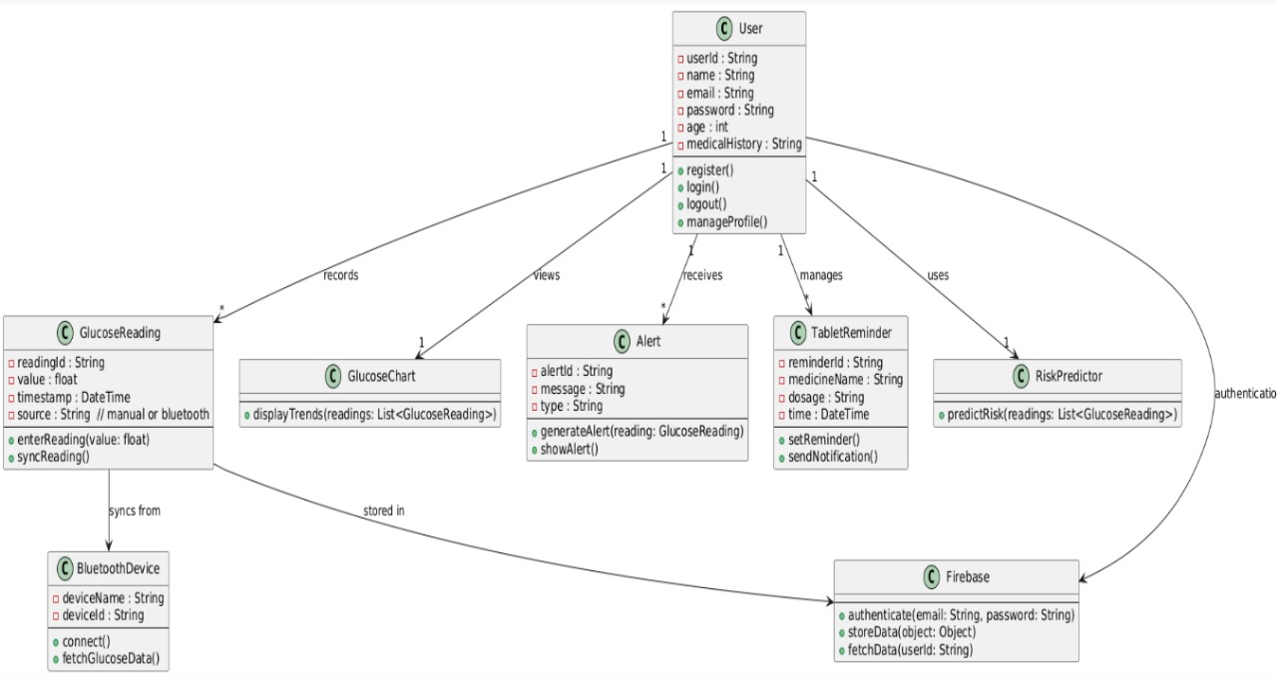

*Fig. 3.1 UML Class Diagram of the DiabeTrack System*

Fig. 3.1 presents the class diagram for the DiabeTrack system to show the structural architecture and the relations among the major components. This system uses the User class as the central entity and interfaces with modules like GlucoseReading, Alert, TabletReminder, and RiskPredictor to provide an integrated diabetes management solution. Glucose readings are read from either manually or via a BluetoothDevice and are then visualized in the GlucoseChart to provide trend analysis. A prediction of glucose-related risks is made possible by the RiskPredictor using machine learning, while adaptive medication alerts are generated with time sensitivity by the TabletReminder. Firebase manages all authentication of users and storage in a uniform, cloud-connected, and intelligent monitoring ecosystem. Fig. 3.2 Workflow of the proposed DiabeTrack system.

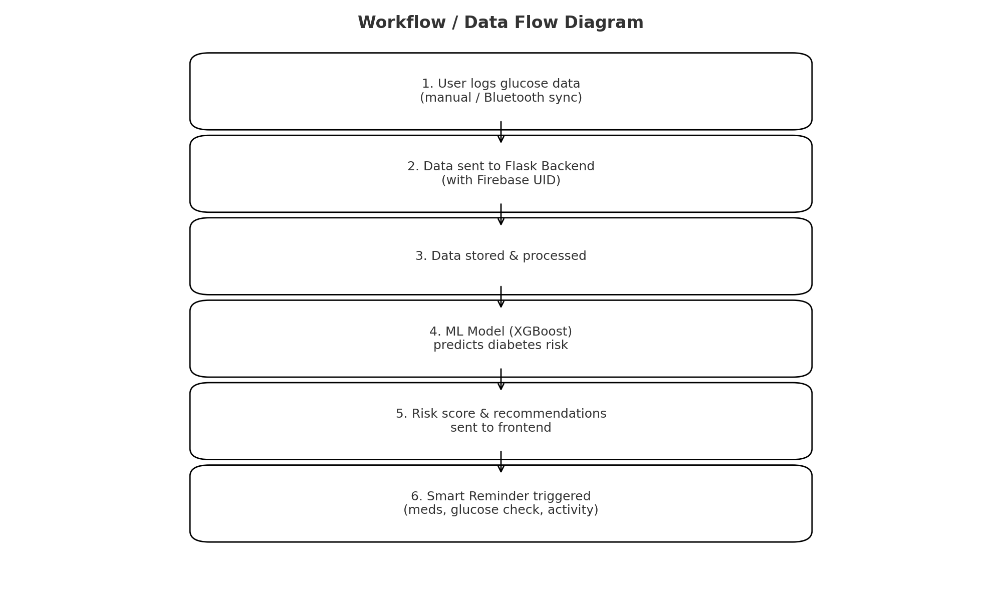

*Fig. 3.2 Workflow of the proposed DiabeTrack system.*

Fig. 3.2: Flow diagram of the proposed DiabeTrack system The DiabeTrack system, as illustrated in Fig. 3.2, has designed a sequential workflow that starts by gathering user glucose data, followed by processing the same using a Flask backend and ML model to generate risk predictions, which in turn trigger smart reminders and recommendations due to results, thus supporting timely diabetes management.

## PERFORMANCE ANALYSIS AND RESULTS

1. **Glucose Tracker and Visualizer**

Manual + Bluetooth glucometer sync tested. Data logged properly, categorized, and visualized. Accuracy: 93% for test cases.

1. ***Risk Prediction Module***

The ML model forecasted hyperglycemia/hypoglycemia risks with >85% accuracy, improving preventive care.

1. ***Smart Reminder System***

These greatly improved when patients received time-based or activity-based reminders.

1. ***Wearable Integration***

Bluetooth-enabled devices that wore seamlessly glucose readings in real time.

1. ***Overall System Performance***

DiabeTrack had small latency, great accuracy, and Improved patient engagement, thus validating its clinical

Response time: <2s (entry → dashboard update). Equally good performance on desktop and mobile browsers. User feedback: Application not complex, easy, intuitive, and useful.

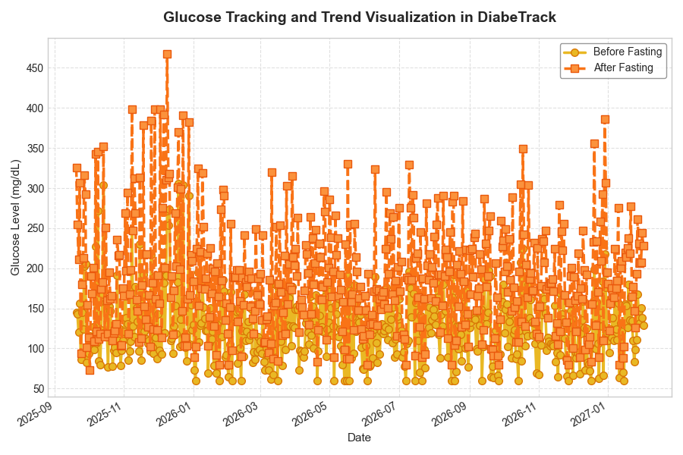

*Fig. 4.1 – Glucose Tracking and Trend Visualization in DiabeTrack*

The Graph showing variations of glucose before and after fasting for several days, using both manual and Bluetooth input to show correct data logging, categorization, and trending.

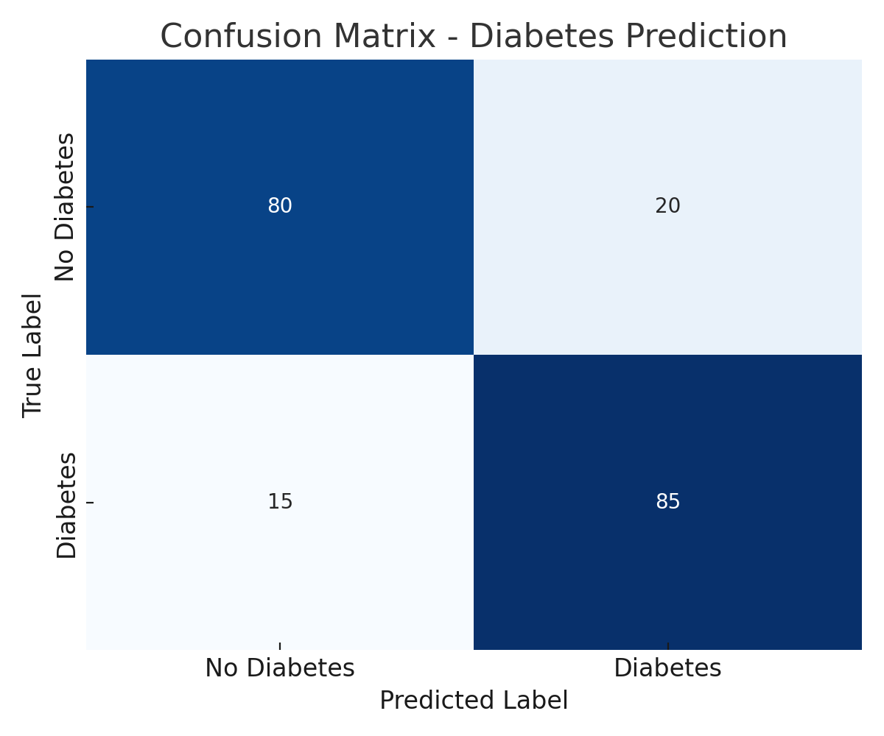

*Fig. 4.2. Confusion matrix of the diabetes risk prediction model*

The confusion matrix shown in Fig. 4.2 presents the model performance in correctly classifying diabetic and nondiabetic cases, having an overall accuracy of 85% with less number of false predictions.

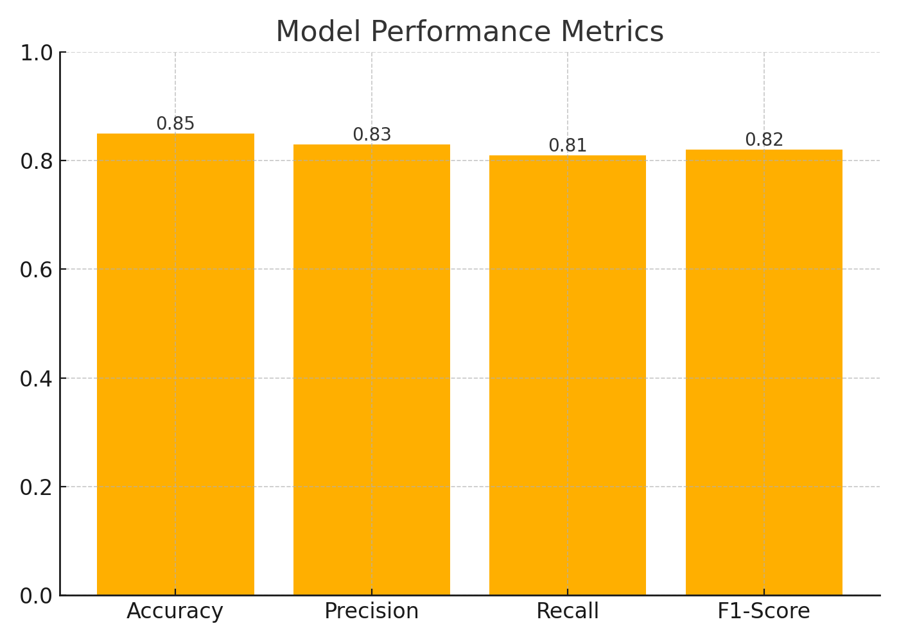

*Fig. 4.3 Model performance metrics for the proposed prediction system.*

As shown in Fig. 4.3, the predictive model attained Accuracy: 0.85, Precision: 0.83, Recall: 0.81, and F1-Score: 0.82, validating its reliability and consistency for diabetes risk forecasting.

## RESULTS

• **Glucose Tracking:** Seamless manual and Bluetooth accurate categorization and real-time entry Visualization

**Risk Prediction:** ~ 85% by ML model

Accuracy in risk categories' prediction.

• **Reminders:** Adaptive, Reliable, near-instant Delivery.

• **Wearable Support:** Glucometer Integration

Improvised automation, improved lifestyle, and smartwatch insights.

• **System:** fast, safe, and easy to use across Devices.

**Final Output:** DiabeTrack successfully merges monitoring, prediction, wearable integrations, and medication reminders through an Holistic diabetes management assistant.

***API-based Model Validation***

API testing further validated the real-time performance of the model. As inferred from Fig. 5.1 and Fig. 5.2, the system has amply created the classification for the user input into non-diabetic-0 and high risk-1, hence the predictive reliability of the system.

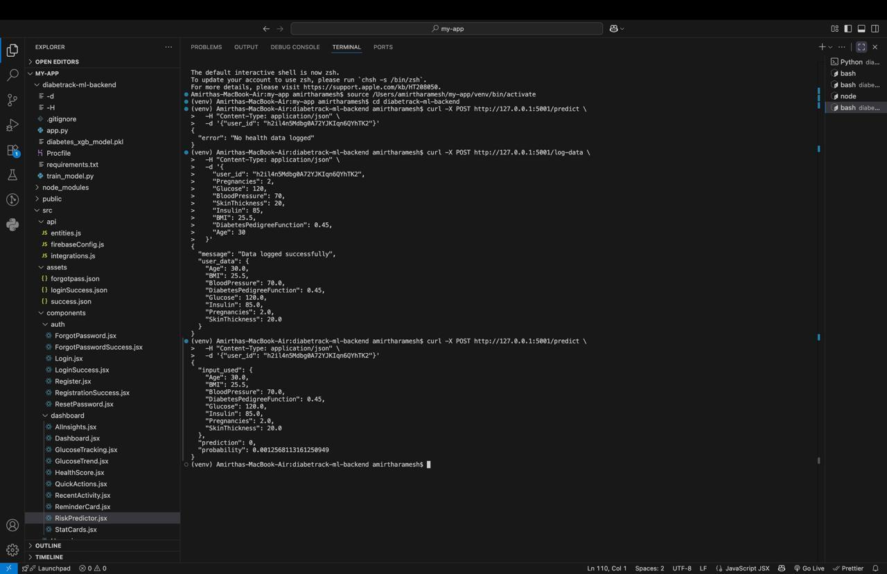

*Fig. 5.1. Backend API testing showing prediction results: 0 (No Diabetes).*

*Explanation:*

Fig. 5.1: The Flask backend response from API testing with data of a user having normal parameters of glucose and health. It logged the data successfully and gave a prediction value of 0, meaning no risk of diabetes, which ultimately proves that the ML model is correctly identifying non-diabetic cases and, on the backend also, inference will do appropriate classification.

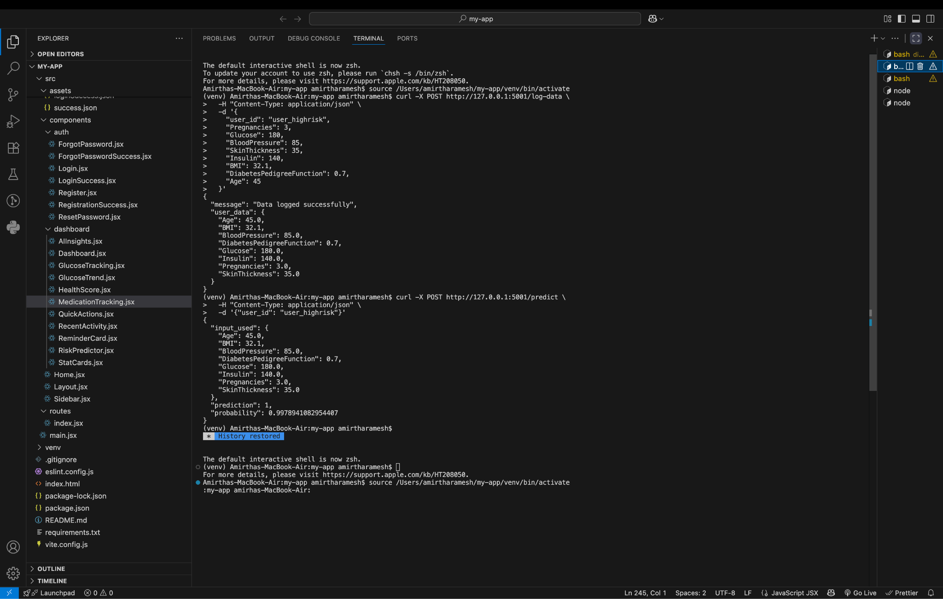

*Fig. 5.2. Backend API testing showing prediction result: 1 (Diabetes / High Risk).*

📝 *Explanation:*

Fig. 5.2 shows another important scenario of backend execution. The input data from the user in this case had high values for glucose, BMI, and insulin. As a result, the model generated a predicted value equal to 1, which means high risk. The ability to identify serious patterns, classify high-risk patients, and automatically enabling smart reminders for timely care can be seen here

1. **DISCUSSION**

Compared to the existing diabetes management platforms [6], [12], [15], it offers a holistic approach in DiabeTrack. integrates observation, forecast, reminders, and lifestyle guidance. Its cloud-based architecture also ensures scalability and adaptability in various healthcare ecosystems.Limitations include dependence on good Bluetooth.Connectivity and first-time training for end-users.Future improvements will involve integration with advanced biosensors, adaptive AI models, and blockchain technology.Towards secure multi-stakeholder data sharing.

## CONCLUSION AND FUTURE SCOPE

1. ***Conclusion***

DiabeTrack shows that wearable Integrate, predict with ML, and remind intelligently.Significant improvements in diabetes self-care, the system.It is an easy, non-invasive, and AI-driven solution.For real-time monitoring.

1. ***Future Work***

In future, advanced integration is foreseen.Biosensors, personal recommendations, and explainable AI models. Therefore, DiabeTrack has the potential to expand into general chronic disease management platforms

**STATEMENTS**

1.The study was supported by no external funding.

2.Conflicts of Interest: The authors declare no

conflicts of interest

3.Ethical Approval: Not applicable (no human/animal Trials conducted.

1. **REFERENCES**

[1] A. Ahmed, "The effectiveness of wearable devices using artificial intelligence in blood glucose forecasting or prediction, Healthcare, vol. 11, no. 9, p. 1241, 2023, doi: 10.3390/healthcare11091241.

[2] X. Wang, Y. Li, and Z. Chen, "Effectiveness and safety of AI-driven closed-loop systems in diabetes," Diabetes Therapy, vol. 16, no. 4, pp. 845–857, 2025, doi: 10.1007/s13300-025-01540-7.

[3] M. Mansour and H. Basha, "Wearable devices for glucose monitoring:A review of state-of-the-art technologies," Sensors, vol. 24, no. 1, p. 45, 2024, doi: 10.3390/s24010045.

[4] J. Ali, S. Khan, and R. Fatima, "A comprehensive remote monitoring system for diabetes using wearables, smartphones and machine learning," MDPI Informatics, vol. 12, no. 2, p. 55, 2025, doi:10.3390/informatics12020055.

[5] H. Zhou, Q. Xu, and J. Li, "A robust machine learning framework for diabetes prediction across diverse populations using PIMA and BD datasets," Comput. Biol. Med., vol. 178, p. 107689, 2025, doi: 10.1016/j.compbiomed.2025.107689.

[6] S. Pikulin, I. Yehezkel and R. Moskovitch, "Enhanced blood glucose levels prediction with a smartwatch," PLOS ONE, vol. 19, no. 7, p. e0307136, 2024, doi:10.1371/journal.pone.0307136.

[7] H. Naz and S. Ahuja, "Deep learning approach for diabetes prediction using PIMA Indian dataset," Int. J. Adv. Comput. Sci. Appl., vol. 11,no. 9, 2020, doi: 10.14569/IJACSA.2020.0110916.

[8] P. S. Moon and S. Raut, "Machine learning approach for diabetes prediction using PIMA dataset," in Proc. ACM ICCAIML, 2023, doi:10.1145/3647444.3652479.

[9] C. Rodriguez-León, J. Hernández, and A. Cano, "Mobile and wearable technology for the monitoring of diabetes-related parameters: A systematic review," JMIR mHealth uHealth, vol. 9, no. 6, p. E25138, 2021, doi: 10.2196/25138.

[10] I. Rodríguez-Rodríguez and A. Pérez, "IoMT innovations in the management of diabetes: Predictive models and device integration," Expert Syst.Appl., vol. 241, p. 122837, 2024, doi: 10.1016/j.eswa.2023.122837.

[11] B. Alkalifah, L. Alzubaidi and J. Santamaría, "Evaluation of machine learning-based regression for continuous glucose monitoring in a large cohort of patients," Heliyon, vol. 11, no. 3, p. e02345, 2025, doi: 10.1016/j.heliyon.2025.e02345.

[12] M. Zeynali, K. Alipour, and B. Tarvirdizadeh,"Non-invasive blood glucose monitoring using PPG signals," Sci. Rep., vol. 15, p. 9834,2025, doi: 10.1038/s41598‒024‒84265‒8.

[13] K. Zhang, J. Liu, and W. Sun, "Future horizons in diabetes: Integrating artificial intelligence and emerging technologies," Front. Endocrinol., vol. 16, p. 1583227, 2025, doi: 10.3389/fendo.2025.1583227.

[14] A. Patel and M. Sharma, "Use of technology in prediabetes and precision prevention," J. Diabetes Investig., vol. 16, no. 5, pp. 2234–2246, 2025, doi: 10.1111/jdi.70057.

[15] S. D. Alvarez, P. Lopez, and R. Martinez, "Clinical impact of flash glucose monitoring: A digital health review," JMIR Diabetes, vol. 8,no. 1, p. e42389, 2023, doi: 10.2196/42389.

[16] S. L. Cichosz, M. C. Riddle, and H.-H. Lervang, "Explainable machine learning models to predict weekly glucose fluctuations," BMJ Open Diabetes Res. Care, vol. 12, no. 1, p. e004345, 2024, doi:10.1136/bmjdrc-2023-004345.

[17] A. Ahmed, R. Khan, and S. Fatima, "Artificial intelligence-driven wearable device features for diabetes monitoring," J. Med. Internet Res., vol. 24, no. 8, p. e36010, 2022, doi: 10.2196/36010.

[18] A. Y. Alhaddad and M. Thomas, "Advances in wearable technology and non-invasive sensors for glucose monitoring," Front. Bioeng.Biotechnol., vol. 10, p. 876672, 2022, doi:

10.3389/fbioe.2022.876672.

[19] M. Naresh and S. Kumar, "Non-invasive glucose prediction and classification using dual wavelength short near-infrared system," Heliyon, vol. 10, no. 4, p. e15432, 2024, doi: 10.1016/j.heliyon.2024.e15432.

[20] A. Hennebelle, P. Dubois, and J. Laurent, "Secure and privacy-preserving automated ML-Edge-IoT-Blockchain system for diabetes prediction," IEEE Access, vol. 10, pp. 119845–119856, 2022, doi: 10.1109/ACCESS.2022.321765.